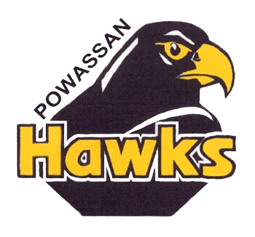

*YOU ARE INVITED AS A SPECIAL GUEST TO OUR GAME ON SUNDAY OCTOBER 14TH VS KIRKLAND LAKE (2PM)*

*GAME INCLUDES:*

* *FREE ADMISSION!! FOR YOUTH PLAYERS WEARING THEIR MINOR HOCKEY JERSEY*
* *GAMES FOR PRIZES BETWEEN PERIOD*
* *POST GAME TOUR OF THE LOCKER ROOM AND MEET & GREET WITH THE VOODOOS PLAYERS AND STAFF*

*SOME THINGS WE ASK:*

* *PLEASE RSVP BY OCT 1ST TO LET US KNOW IF/HOW MANY ARE ATTENDING (WE WANT TO MAKE SURE WE SAVE TICKETS FOR YOU)*
* *WE ASK THAT FOR EVERY 5 KIDS THERE IS 1 ADULT (FOR SUPERVISION)*
* *ADULT TICKETS ARE STILL REGULAR PRICE*
* *MOST IMPORTANT IS CHEER AS LOUD AS YOU CAN AND HELP THE VOODOOS BRING IN ANOTHER WIN*

*WE HOPE TO SEE YOU AT THE RINK ON OCTOBER 14TH AND LOOK FORWARD TO MEETING ALL OF YOU!!!!*

*GO VOODOOS AND GO HAWKS!!*