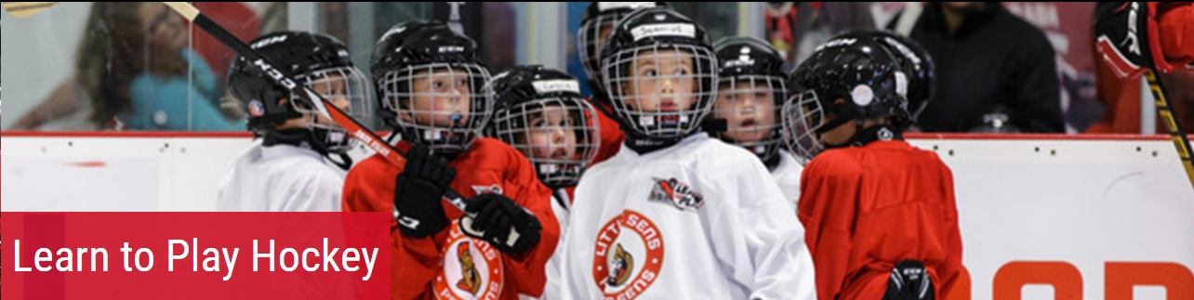
Little Sens Learn to Play is coming to Powassan/East Nipissing for the 2018-2019 season!
The Ottawa Senators, the National Hockey League and the NHL Players Association are pleased to provide the Little Sens - Learn to Play program, an introductory program for children 4 to 8 years old.
Participants will receive:
- 10 weeks of one hour cross-ice instructional sessions
- Head-to-toe Little Sens hockey equipment
- Visits by Senators Alumni
Sessions will run from October 6th-December 8th 2018
Sessions alternate between Powassan Sportsplex and East Ferris Community Center.

To register and learn more about the program please visit www.ottawasenators.com/littlesens.

*As a reminder, participants must be able to skate the length of the ice with minimal assistance to register in this program. If your child cannot skate on their own we highly recommend the Sparty Learn to Skate program or a similar program to teach skating.
If you have any questions about the program please contact littlesens@ottawasenators.com or 613-271-5657.

