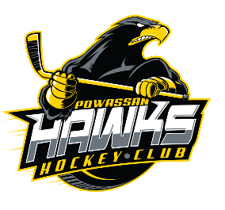
PMHA Code of Conduct Acknowledgement and Agreement
The Code of Conduct applies to all Powassan Minor Hockey Association participants (including without limitation players, parents/guardians and coaches/team management, officials, volunteers, officers and directors participating in PMHA activities.
Every PMHA player agrees that she or he will conduct themselves as per the Player’s Code
Every parent or guardian of a PMHA player will conduct themselves as per the Parent / Guardian Code
Every PMHA Coach, Assistant, Manager, Trainer and other member of team management acknowledges that she/he is in a position of trust and authority and will conduct themselves as per the Team Officials Code.
Every member is expected to conduct themselves as expected in the All Members’ Code

Powassan Minor Hockey Association Code of Conduct Acknowledgement and Agreement

I ___________________________________________________ (print name) acknowledge and agree with the Code Of Conduct.

I ___________________________________________________ (print name) acknowledge and agree with the Code Of Conduct.

I ___________________________________________________ (print name) acknowledge and agree with the Code Of Conduct.

I ___________________________________________________ (print name) acknowledge and agree with the Code Of Conduct.

Date: __________________________

Name (print) | Signature

